# Introduction

* There are several joystick options in the MMC library, but there currently is not a bigger or more durable than the Oak Joystick
* The Ultrastik Joystick is bigger option but does not come with an enclosure.
* Several enclosure options exist, but are either commercial or not optimized for makers.

**User focus:**

* Gamers with gross motor movement and high strength

# Research

## Commercial options

|  |  |
| --- | --- |
| Title | Quadstick Ultrastik 360 |
| Link | [Quadstick](https://www.quadstick.com/shop/ultimarc-utrastik-360-enclosure) |
| Author | Quadstick - Fred |
| License | Commercial |
| Cost | $204 CAD |
| Notes | Most popular solution for getting Ultrastik’s in North America |

|  |  |
| --- | --- |
| Title | Ultra-Stik |
| Link | <https://oneswitch.org.uk/page/shop-ultra-stik> |
| Author | Barrie Ellis – OneSwitch |
| License | Unknown |
| Cost | $174 CAD |
| Notes | Most popular solution for getting Ultrastik’s in Europe |

## DIY designs

|  |  |
| --- | --- |
| Title | OneSwitch – DIY [Instructions ONLY] |
| Link | [OneSwitch - DIY](https://oneswitch.org.uk/art.php?id=73) |
| Author | Barrie Ellis – OneSwitch |
| License | N/A |
| Cost | Free |
| Test Build (Y/N) | N/A |
| Add to Library (Y/N) | No but credit them in this design |
| Notes |  |

|  |  |
| --- | --- |
| Title | UltraStik – SCCR |
| Link | [SCCR Printables](https://www.printables.com/model/268854-ultrastik-analog-joystick-enclosure) |
| Author | SCCR – Rachelle Bernier |
| License | CC attribution-shareAlike |
| Cost | $100 CAD |
| Test Build (Y/N) | N/A |
| Add to Library (Y/N) | No but credit them in this design |
| Notes |  |

|  |  |
| --- | --- |
| Title | Ultrastik - Gearhead |
| Link | [Gearhead Printables](https://www.printables.com/model/510023-housing-for-ultimarc-ultrastik-360) |
| Author | Gearhead (printables username) |
| License | GNU v2.0 |
| Cost | $100 CAD |
| Test Build (Y/N) | N/A |
| Add to Library (Y/N) | N |
| Notes |  |

# Requirements

## Goals

|  |  |
| --- | --- |
| G01 | Act as a larger and durable form factor for our joystick line. |
| G02 | Provide an option for users who are breaking the internals of the Oak Joystick. |
| G03 | Maker manufacturable in quantities of one. |
| G04 | The use of support material in 3d printed components should be minimized. |
| G05 | The number of different filament types should be minimized. |
| G07 | Material costs should be minimized as to provide a low cost options (Less than or equal to $100 CAD) |

## Functional Requirements

|  |  |
| --- | --- |
| F01 | The joystick shall be usable from a the distance given by the USB cable supplied by UltraStik |
| F02 | The joysticks shall be compatible with the Xbox Adaptive Controller. |
| F03 | Joysticks shall be PC compatible. |
| F04 | The joystick shall denote use orientation. |
| F05 | The joystick shall have a range of easily interchangeable toppers. |
| F06 | Toppers shall not interfere with the regular physical motion of the joystick. |
| F07 | Toppers shall have a secure connection to the joystick. |
| F08 | The joystick shall be designed to be used by either hand. |
| F09 | Joystick shall remain stable when in use. |
| F10 | The housing shall protect internal components from outside sources. |
| F11 | Joystick designs shall support camera mounting styles. |
| F12 | Joystick designs shall support hook and loop fastener mounting styles. |
| F13 | Joystick designs shall support tabletop mounting styles with no fasteners. |
| F14 | Enclosure shall work with the Ultrastik joystick component |

## Non-functional Requirement

|  |  |
| --- | --- |
| NF01 | Documentation should be maintainable with the use of commonly available software. |
| NF02 | Documentation must be available in a digital format. |
| NF03 | Documentation must be printable. |
| NF04 | Documentation, code, and hardware must have appropriate open-source licenses. |
| NF05 | Instructions must be provided for using joystick with XAC for gaming |
| NF06 | Instructions must be provided for using joystick with PC/Phone/Tablet for gaming |
| NF07 | Instructions must be provided for using joystick with PC/Phone/Tablet for digital access |

## Constraints

|  |  |
| --- | --- |
| C01 | Joystick must be maker manufacturable. |
| C03 | Not for use with mobility devices. |
|  | The joystick shall be based on the commercially available Ultrastik 360 Analog Joystick. |
|  | The Ultrastik 360 Analog Joystick has an approximate activation force of 298 grams. |
|  | The Ultrastik 360 Analog Joystick has an X and Y axis range of ±15.5° |
|  | The Ultrastik 360 Analog Joystick has a linearity of TBR (no info from manufacturer) |
|  | The Ultrastik 360 Analog Joystick has a mechanical lifecycle of TBR (no info from manufacturer) |
|  | The Ultrastik 360 Analog Joystick has an operating temperature range of TBR (no info from manufacturer) |
|  | The Ultrastik 360 Analog Joystick has an envelope of 96 mm high 95 mm wide x 78.1 mm deep (with mounting plate attached) |
|  | 3D printed components shall be printable within a 180x180x180mm print volume. |

# Ideation

* Prevent using screws coming from the top enclosure if possible
  + This may be able to be prevented with the use of the dust cover. Need to investigate
* The top of the joystick component should allow room for the dust cover
* No easily source able size of bolt will allow for a design where the bolt comes through the bottom side of the joystick component into a enclosure without spacers
* Toppers
  + Use Oak toppers by adapting the 3D printed nut to fit onto the ultrastik

# Conceptual Design

Initial conceptual design was conducted using a modified version of the [SCCR Printables](https://www.printables.com/model/268854-ultrastik-analog-joystick-enclosure) ultrastik enclosure. The following was modified:

* Insert holes on the top enclosure for the bolts. These were altered to fit M5 bolts.
  + Chamfers were also added for ease of assembly
* Spacers were added for the M5x12 bolts to allow the joystick component to sit at the same height as the SCCR option.
* General fillets were added to the top part of the enclosure to ensure force distribution and prevent shearing of 3D printed parts
* The topper nut from the Oak Joystick was modified to fit a M6 nut inside to secure the toppers to the Ultrastik component.

## Concept 1 – SCCR Modification

### Assembly

Assembly is compromised of the following parts:

1. Ultrastik joystick unit
   1. USB-Mini to USB A cable
   2. Ball topper
   3. Dust washer cover
2. Top Enclosure
3. Bottom Enclosure
4. 4x M5x12 bolts
5. #?? Machine Screws
6. 4x Bolt spacer
7. 1x M6 nut
8. 1x Joystick topper adapter

Images of parts:

|  |  |
| --- | --- |
|  |  |

The steps to assembly are:

1. Put the dust cover washer onto the joystick component
2. Put the joystick component into the top base
3. Line up the bolt holes with the holes on the joystick component
4. Place the spacer between the bolt holes and M5 bolt
5. Screw down all M5 bolts to secure the joystick component to the top of the enclosure
6. Attach the USB cable to the joystick component and place the cable zip tie it to the strain relief attachment
7. Attach the bottom of the component with the small machine screws

### Bottom enclosure

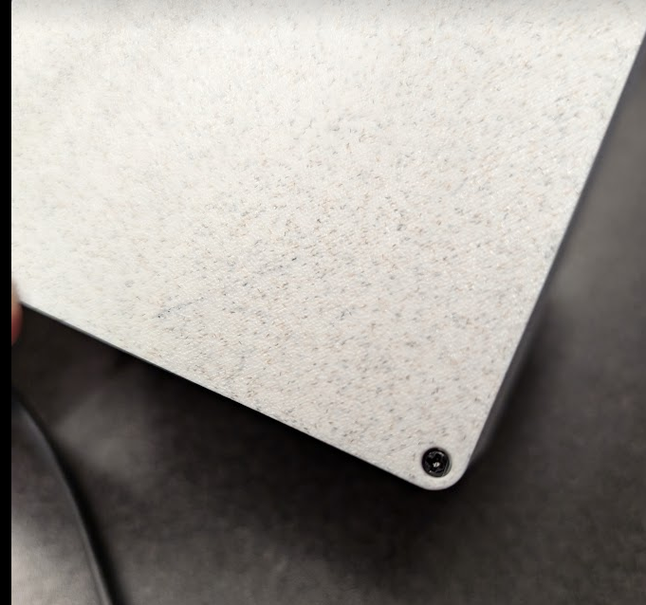

* These are quite close to the edge and are likely not big enough to keep the base secured to the top part of the enclosure if someone had it fastened to a mount or table with hook and loop.

### Top Enclosure

|  |  |
| --- | --- |
|  |  |

* Left picture is without dust cover and right is with dust cover. The dust cover slides underneath nicely but is quite loud. Consider making a track for it to follow underneath to prevent rocking.
* Dust cover adds a higher quality feel and helps prevent fluids, dust, and grime getting inside the joystick. This is also standard for most arcade style fighting joysticks.

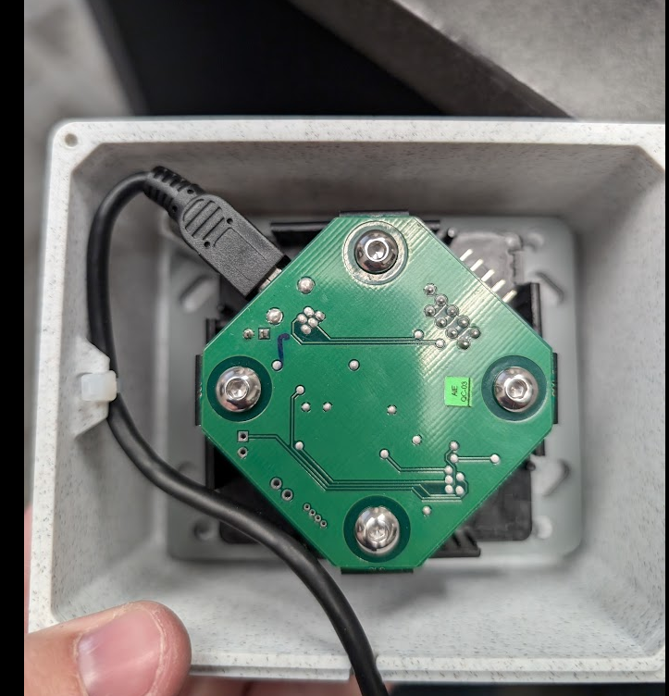

* Bolt hole locations for the four corners of the joystick component are very close but could be lined up better.

### Toppers

|  |  |
| --- | --- |
|  |  |

* M6 nut fits nicely inside the joystick topper adapter.
* A 2mm gap was chosen between the bottom of the joystick adapter and start of threads on the M6 nut.
  + This choice worked well as the base of the joystick topper adapter has strength in the bottom to resist puncture from joystick topper.

|  |  |
| --- | --- |
|  |  |

* Assembly of the joystick topper adapter on the threads of the joystick component could be improved
  + When first starting the threading, you have to push the joystick topper adapter up and with the other hand push the nut down into the cutout for it.
  + Once threads are started, to screw down you have to lift up on the joystick topper adapter at the same time
* This can be improved with a lid or some way to more permanently fix the M6 nut into the joystick topper adapter.

|  |  |
| --- | --- |
|  |  |
|  | |

* All Oak joystick toppers fit as expected onto the joystick topper adapter
* The sizing of the toppers is appropriate for the joystick and does not restrict movement.

## Concept 2 – Vertical Split Housing

### Snap Fit Enclosure

* Also designed by SCCR, a modified version of the enclosure was made for assistive switch port and snap fit with a vertical cut. Photo below:

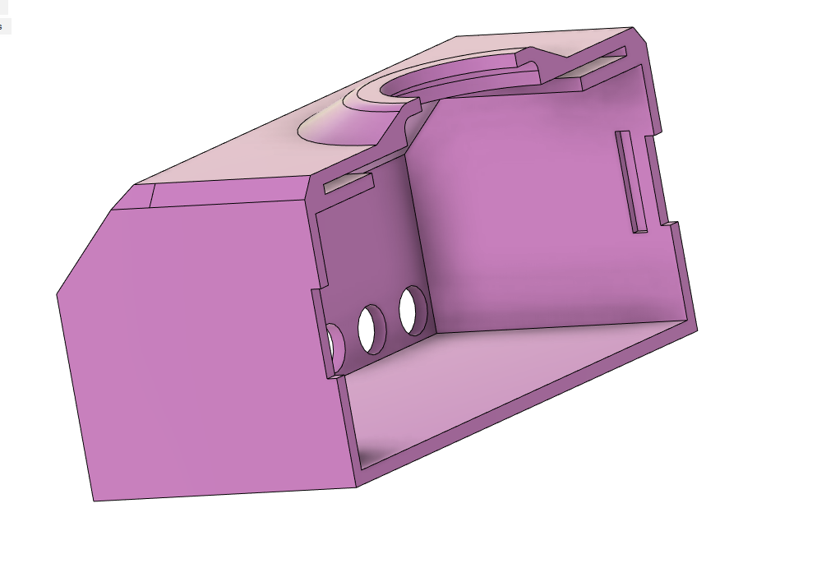

* The top plate of the Ultrastik joystick can be used to fix the vertical location of the joystick and the enclosure can snap around it to lock it into position

### Non Snap Fit

* Same idea except using fasteners to attach the two sides of the enclosure together

## Concept 3 – Built in Spacers

Similar to the Gearhead 3D print model that is on Printables, there could be a version where the spacers are attached to the enclosure. See photo below:  
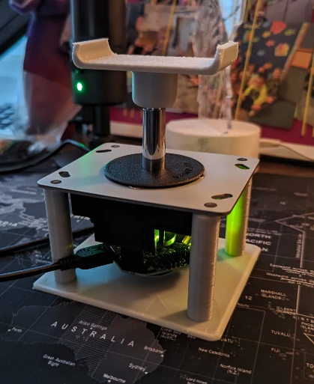

* We would want to avoid the bolts being attached through the top of the enclosure to prevent abrasion to the user.

# Prototyping

Concept 1 was chosen to be the first MVP design to get to the Movement Centre for testing as the designer was heading there for GAME Checkpoint training. This was designed in CAD, tested, and trialed during the Movement Centre.

## Recreating the Ultrastik Joystick Component

There is not currently an official or verified open-source CAD model of the Ultrastik Joystick. As such, a CAD model was designed with a physical unit available to the designer. Utilizing physical measurements with a caliper and using the canvas feature in Fusion an approximate model was created.

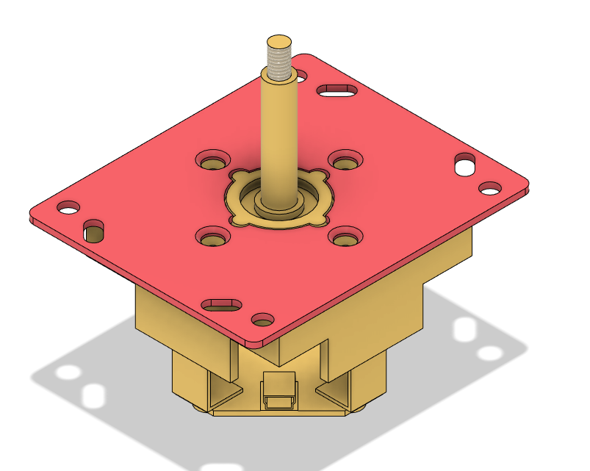

Key measurements and features of the Ultrastik can be seen below:

* Outer mounting holes on the mounting plate fit size M5 bolts.
* Screws holding the mounting plate onto the joystick component is M4x10 countersunk.

## ROM of Joystick

Measured in person with a physical unit using a protractor to be approximately 16.5 degrees. To verify approximation, photos were added to Fusion and the angle was estimated there to be 14.426 degrees. The different is taken to be approximately 15.46 degrees and rounded up to 15.5 degrees.

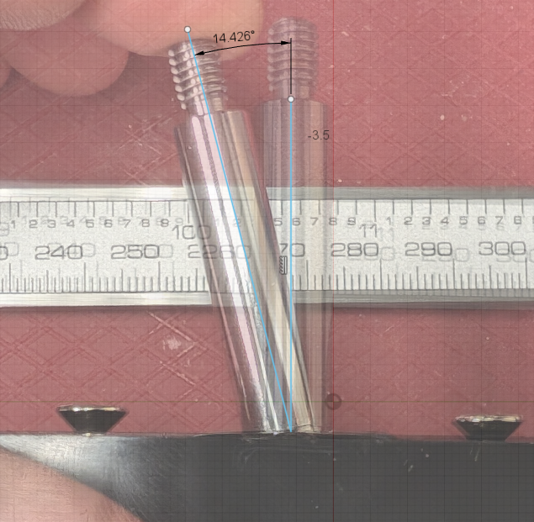

## Joystick Position Relative to Top Enclosure

If there is some type of attachment mechanism inside the top enclosure such as imbedded nuts, screw holes, etc there may be distance between the top of the Ultrastik joystick and top enclosure. It is necessary to determine what the maximum distance would be allowed between the top of the Ultrastik joystick and upper enclosure.

The main considerations we have to design for here are:

1. When any of the Oak sized toppers are added, they do not collide with the top of the enclosure
2. Have as much of the stick that is protruding out of the top of the enclosure as possible to align with the other standard commercial options.
3. It does not restrict with the ROM of the device in any way.

For reference, SCCR’s enclosure has a 3.5 mm distance between the Ultrastik mounting plate and inner top of the enclosure.

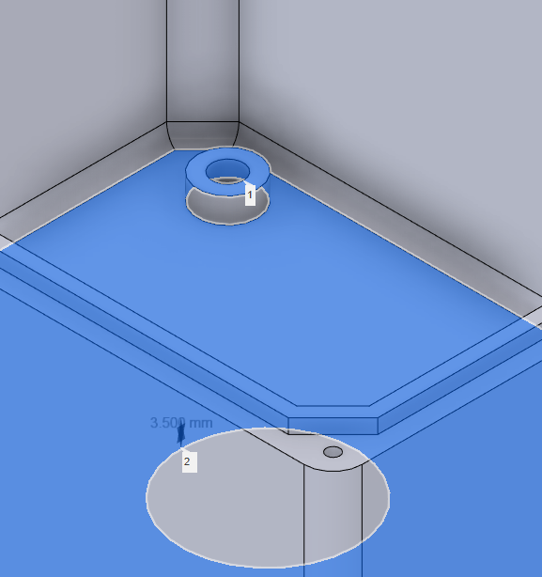

Whereas the Gearhead, One Switch, and Quadstick designs attach the joystick with screws from the top of the enclosure resulting in a 0 mm distance between the Ultrastik mounting plate and inner side of the top of the enclosure. See the Gearhead example below:

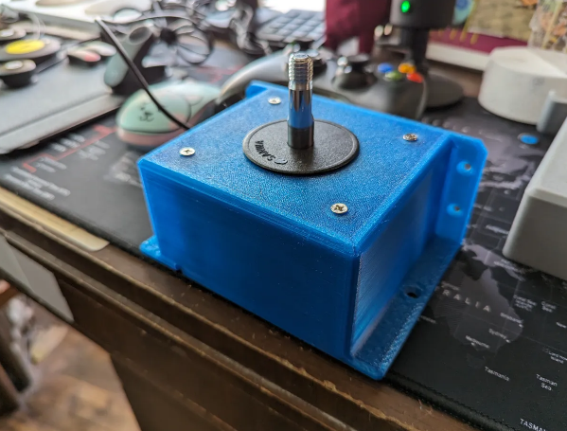

The unit I tested with at the Movement Centre used a 3.5 mm distance like the SCCR design (see testing notes below). This distance did not cause any undesirable effects regarding the three considerations above.

# Testing

## Movement Centre Feedback

* Tested with 4 gamers and 4 clinicians from the Movement Centre during GAME Checkpoint training and open house.
  + Out of the 4 gamers we tested with, 2 of them found it useful. The other 2 needed shorter joysticks such as the Spruce/Oak
  + All 4 clincians used it to trial adaptive gaming setups.

|  |  |
| --- | --- |
|  |  |

Feedback:

* For the 2 gamers the form factor worked for, this was the joystick of choice out of the Oak, Spruce and Ivy.
* Clinicians liked the larger form factor and that it was compatible with the same toppers.
* Both clinicians and gamers disliked that the post of the Ultrastik joystick spins. This was difficult if the gamer did not have stability in their wrist or arm to keep the joystick topper straight.
  + Toppers like the stick or ball were opted for instead of directional toppers like the goalpost.

## 3D printing Feedback

* After first initial print/test with the Movement Centre, clear improvements were identified. Wait until these improvements are made on the model until sending to Josie for 3D printing feedback.

# Detailed Design

## Style of Top Enclosure

### Attachment of Joystick Unit to Enclosure

There are a few options that were considered when thinking about the attachment of the Ultrastik unit to the enclosure. First lets consider the options and criteria to begin to evaluate. Here are the methods of attachment:

1. Using the included M4x10 Machine Screws used to attach the Ultrastik mounting plate to the electronic housing as an attachment to the top face.
2. Use short (<5mm) M5 machine screws to attach through Ultrastik Mounting plate to housing from inside
3. Use a commonly available M5 machine screws to attach through the Ultrastik mounting plate to housing from inside with a bottom enclosure that has integrated spacers. Uses one M5 set of screws for attachment.
4. Use M5 machine screws through the top of the enclosure and a nut on the other side of the mounting plate to secure.
5. Use a snap fit or alternatives such as glue, tape, etc.
6. Using a top, bottom, and spacer 3D printed component that can sandwich between the top and bottom enclosures. Differs from option 3 as spacer is its own part.

The criteria that these options will be evaluated against were determined by the key considerations for this specific device.

* **Consumables -** We currently do not have any M5 machine screws in our common parts list so this is not a consideration to revolve the design around current stock. This allows us freedom for design while using the least number of consumables as possible.
* **Strength –** This will be the heavy duty offering of our joystick line. It must be both robust from the forces acting on the stick and where the mounting platform will be.
  + Minimum thread engagement must be 1 times the nominal diameter which is referenced from [Nord Lock](https://www.nord-lock.com/learnings/bolting-tips/2015/the-experts-thread-engagement-in-a-tapped-hole/#:~:text=It%20is%20commonly%20known%20that,the%20nominal%20diameter%20in%20aluminum.). Therefore 5 mm for the M5 and 4 mm for the M4.
* **User Interaction/Ergonomics –** Size, smooth top surface, and other considerations are important.
* **Assembly complexity** – Not as important as this will likely not be featured in build events due to cost.

The options above were evaluated based off of the criteria. A full decision matrix was not completed due to my own bias. Therefore, a straightforward reasoning was noted below to show a clear thought process:

|  |  |
| --- | --- |
| **Option** | **Evaluation against Criteria** |
| 1 | * **Consumables:**   + Machine screws for the base component to be connected to the top enclosure. * **Strength:**   + Given this is a threaded connection, it will be quite secure given the M4 machine screw will have sufficient thread engagement * **User Ergonomics:**   + This would require screws to enter through the top of the enclosure which bring up other design considerations to prevent abrasions to user.     - A cover could be considered for the top screws if they are imbedded more into the top of the device to prevent this.   + The base of the joystick will be smaller than if the mounting bracket is used. More testing would be required to see if this causes issues. * **Assembly complexity:**    + This can result in the magnetic sensor at the bottom of the joystick being an incorrect distance away from the sensor resulting in drift and inconsistent results. This could be mitigated with quality checking units but considering the circumstances volunteer making I want to avoid this design. |
| 2 | * **Consumables:**   + Sourcing short M5 machine screws is very difficult. There are some on Amazon but with limited quantities.   + No units to purchase on bulk sites such as Digikey. * **Strength:**   + It could be difficult to get the minimum thread engagement needed to keep the joystick close to the top of the enclosure. * **User Ergonomics:**   + This would require screws to enter through the top of the enclosure which bring up other design considerations to prevent abrasions to user.   + Even using a M5x5mm screw, the joystick is farther away from the top of the enclosure than desired. * **Assembly complexity:**    + Lining up the machine screws in the right place with such a deep top enclosure can be challenging. |
| 3 | * **Consumables:**   + Only 4x M5 machine screws needed. * **Strength:**   + It could be difficult to get the minimum thread engagement needed to keep the joystick close to the top of the enclosure similar to commercial products.   + There is a single point of connection for the base and connection to joystick. The force is all being transferred from mounting and joystick are on these 4 machine screws. * **User Ergonomics:**   + No effect on user ergonomics. * **Assembly complexity:**    + Simple assembly as it will have guided path for machine screws. |
| 4 | * **Consumables:**   + Requires nuts as well as machine screws. * **Strength:**   + Strong connection as it does not include self tapping into plastic. * **User Ergonomics:**   + This would require screws to enter through the top of the enclosure which bring up other design considerations to prevent abrasions to user.   + Distance of mounting plate to top of the enclosure is a minimum * **Assembly complexity:**    + To get a secure connection a socket would be required. This is not in the standard bill of materials   + A nut catch could be added as an alternative, but this would add distance from the mounting plate to the top of the enclosure. |
| 5 | * **Consumables:**   + Glue, tape, etc * **Strength:**   + This joystick is designed to be a more heavy duty style for those with limited fine motor movement. With this, strength of the user could be quite high so using other methods of connection are undesirable as they could not be strong enough to bear this force. * **User Ergonomics:**   + Distance of mounting plate to top of the enclosure could be minimum. * **Assembly complexity:**    + Depending on method, this could be quite simple with something like a snap fit or time consuming like glue. |
| 6 | * **Consumables:**   + Requires an additional 3D printed component.   + Set of fasteners for base connection and top connection. * **Strength:**   + Different points of contact for the base connection and joystick to the top enclosure.   + Spacer component can be designed in a way to optimize strength. * **User Ergonomics:**   + No effects on user ergonomics. * **Assembly complexity:**    + Could be difficult to hold everything together while attaching screws. |

Analyzing this, Option 1 was considered for the design approach as it will result in a very strong connection using the threaded holes. It also requires limited amount of consumables utilizing the ones coming with the unit. It will also allow more room within the housing by not using the mounting plate. This will make mounting the bottom enclosure easier. User ergonomics can also be mitigated easily with a cover for the screws.

Option 3 and 6 were also considered but Option 1 was chosen due to the advantage of less consumables, ease of assembly, and increased strength by using the threaded inserts provided by the joystick component.

Therefore, we can remove the mounting plate from the CAD and design moving forward. We are working with the joystick housing and the inner joystick mechanism along with 4 M4x10 countersink machine screws. Photos can be seen below.

|  |  |
| --- | --- |
|  |  |
|  |  |

## Design of Top Enclosure

### Wall Thickness

* Side walls for all of our other current joysticks have a thickness of 1.6 mm which is approx. 4x times a 0.4 nozzle width. This joystick is intended to be more robust and because its highest failure point will likely be the layer lines, the wall thickness was doubled at 3.2 mm.

**With this, at a wall loop set at 4 there will be no support material for the walls or around the screw holes on the top or bottom enclosure.**

|  |
| --- |
|  |

### Enclosure dimensions

|  |  |
| --- | --- |
|  |  |

105.5x105.5x58.7 mm (without stick)

105.5x105.5x107.1 mm (with stick and topper adapter)

* The length and width of this device is determined by the Ultrastik joystick dimensions without the mounting plate and the room needed inside the housings for strain relief and top to bottom enclosure attachment methods.
* Specifically, the overall length and width were determined to be 105.5 mm & 105.5 mm because of the clearance for the mounting between the top and bottom enclosures and space needed for the USB cable to enter the Ultrastik.
* The height was determined to be 105.5 mm because of the wall thickness of 3.2 mm on the top and bottom enclosures and the 58.7 mm height of the Ultrastik joystick housing (not including stick)

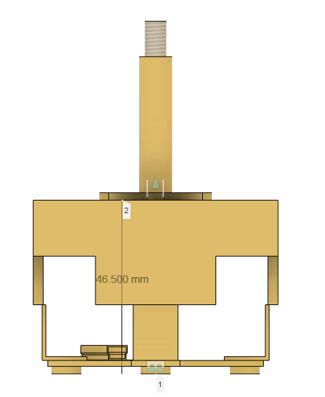

### Hole size for Joystick Stick to Exit

* The diameter of the exit hole for the joystick was chosen to be 19mm. This matches the diameter of the inner diameter of the protruding ring of the joystick component.
* A 2.25 mm deep insert was created on the inside of the enclosure to allow this protruding ring to fit inside. The shape was created by using a 0.25 mm offset to create a slight transitional fit.
  + This will ensure proper hole alignment.
  + The mounting plate the joystick comes with is 2mm thick so a 2mm clearance was required to ensure the same distance of the magnetic sensor as the original mounting plate.
* A small chamfer was added to aid in alignment when adding the Ultrastik Joystick to the housing.

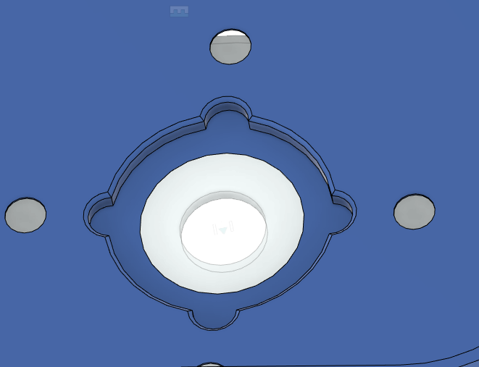

### Screw hole dimensions

* Using the hole tool the presets were chosen for a M4 countersunk, clearance tap, and flat drill point to the other side of the enclosure housing was chosen.
* The fit was specified to loose which changed the clearance tap from 4.5 mm to 4.8 mm

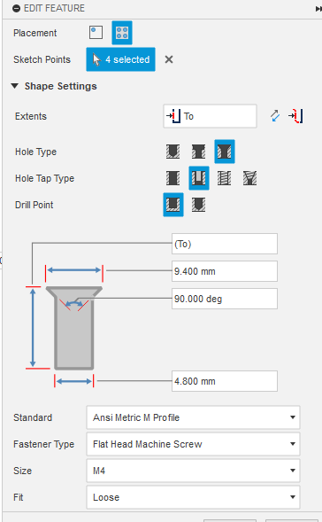

### Exposed Screws

Originally, the thought was to create a part that could be inserted to cover the screw faces and become flush with the top face. However, after some print tests, sinking the screw faces 1 mm into the enclosure and use with the dust cover made the need for a cover irrelevant. There will be no risk for the user to come in contact with the screw faces unless the dust cover is not being used (incorrect usage) or a screw has become loose. More detail on the 1 mm insert and dust cover:

* The method chosen to address the exposed tops of the screws was to create a face 1 mm into the top of the joystick enclosure and create the M4 countersunk holes there. Then extrude a cut to expose the countersink 1 mm down. This results in the screws being 1 mm below the surface of the joystick.
* The dust cover also covers the majority of the screw faces.

|  |  |
| --- | --- |
|  |  |
|  | |

After print testing, this design worked as expected:

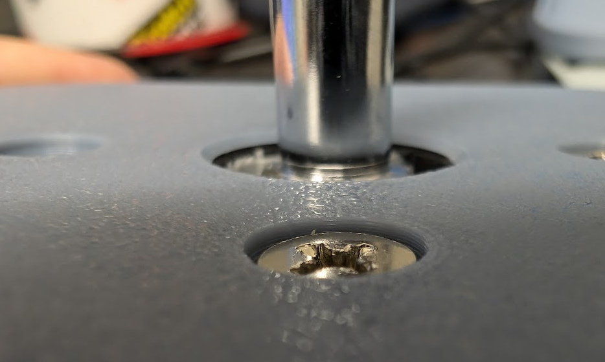

Move forward with this design.

### Indicating Usage Direction

* A arrow was added to the top face of the top enclosure to clearly indicate the “forward” motion of the joystick.
* Similar sizes, fillets, and chamfers were chosen from previous MMC joysticks (Oak, Spruce, Aspen, etc).

### Indicating Assembly orientation

It can be hard to determine how the ultrastik mechanism needs to be oriented so the USB cable is in the right place and therefore the directionality is right. Text was added to the inner face of the top enclosure to help the maker.

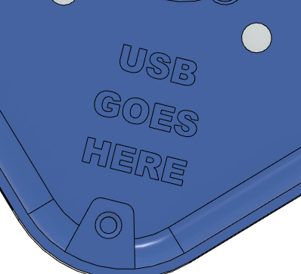

Ideally there would be a way to key this so the maker can not but the joystick in the wrong way but the Ultrastik is symmetrical. This text was chosen and along with the Maker Guide the user will be able to insert the joystick the right way.

### Exit of cable

* A hole was added on the “rear” face of the joystick which will be away from the user and toward the device (computer or adaptive controller) when in use.
* The cable that comes with the Ultrastik has a diameter of 3.7 mm. As such, the hole was designed to be 4.2 mm to allow for a slight transition fit to add some friction for some added strain relief.
* The hole was created between the connection of the top and bottom enclosure to prevent the need for soldering/stripping wire to have the cable exit.
* Based on clinician and user feedback, the port of the USB on the Ultrastik is not accessible while the joystick is assembled. However, if a cable needs to be replaced, the base can be detached to swap them easily.
* A 5 mm fillet was added to smooth the exit and add a refined esthetic look.

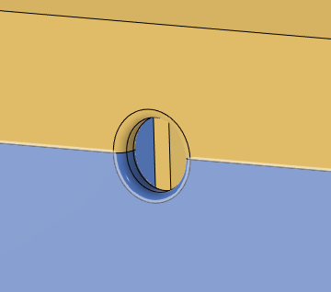

### Strain relief

* Inspiration was taken from the strain relief of the Oak joystick.
* The intention is for the user to slide a zip tie into the strain relief feature inside the top enclosure and use it to attach the provided USB cable.
* There was a 45 degree angle added to the feature so no supports will be needed when printing.
* A large fillet was added inside the slot of the feature to guide the zip tie to exit properly.
* Fillets with 2 mm radii were added to the outside of the feature to aid in printing and strength when force is applied to the cable externally.

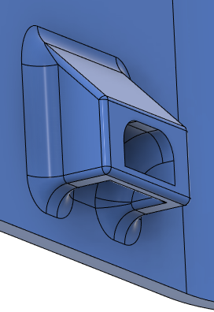

### Outer Chamfer

Set at 3 mm. The chamfer will prevent elephant foot. 3 mm was chosen by esthetics primarily.

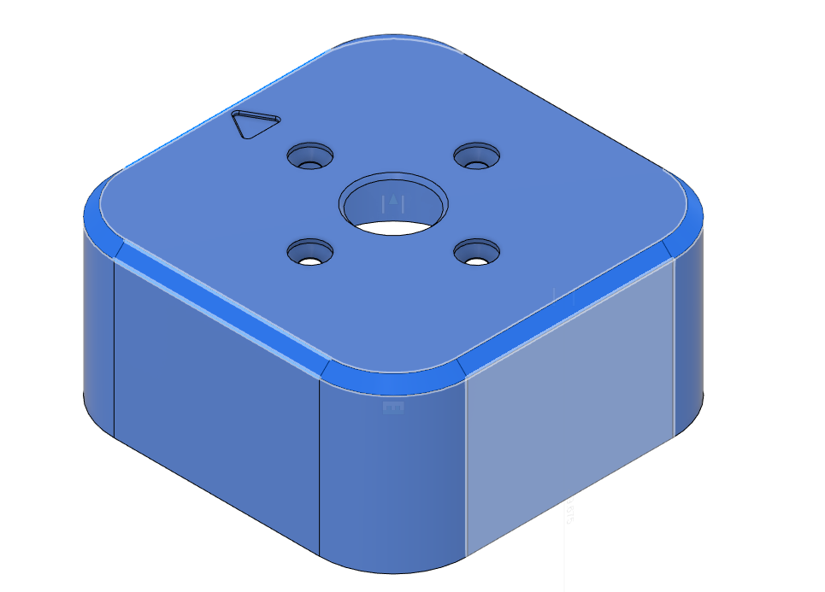

### Outer Fillet

All 4 corners are filleted on the housing. This is to allow for a more esthetic print and avoid sharp corners. Set at 20 mm determined primarily on esthetics.

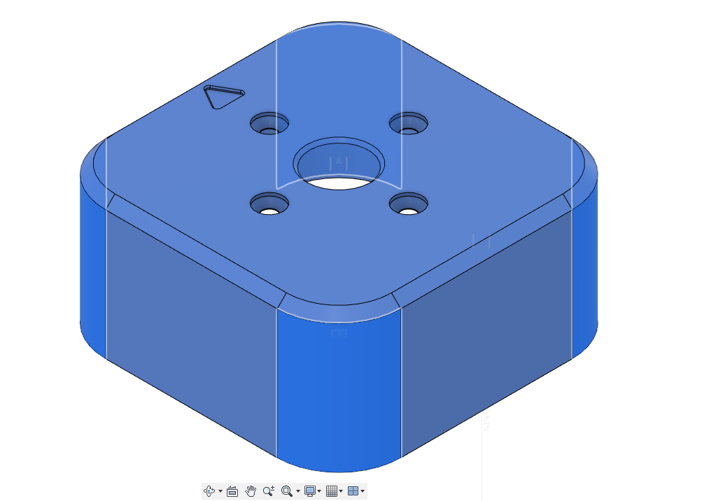

### Inner Fillet

A continuous 5 mm fillet was added to the inside of the top enclosure. This will help reduce strain at the edges of the print.

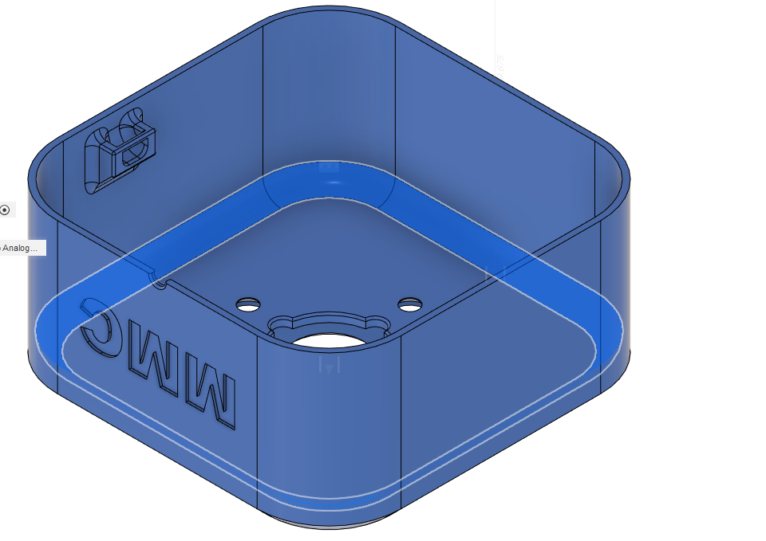

### Attachment to Bottom Enclosure:

Because the device will be mounted from the base on hook and loop fasteners or on a mounting arm through the standard Open AT adapter, the forces acting between the bottom and top enclosures must be considered. With that, what type of attachment between the enclosures needs to be evaluated. See proposed options, evaluation criteria, and evaluation below:

1. Option 1 – Using the common screw part (#4 self-tapping 3/8" length) used in the Oak joystick with a similar features on the top and bottom enclosures. Self tapping into a plastic feature
2. Option 2 – Snap fit
3. Option 3 – Bolt/nut catch style. Using a 3D printed feature on the top enclosure as a nut catch. A bolt then will be inserted from the bottom enclosure.

The criteria that these options will be evaluated against were determined by the key considerations for this specific device.

* **Consumables –** Utilizing common parts or no parts are prioritized.
* **Strength –** This will be the heavy duty offering of our joystick line. It must be both robust from the forces acting on the stick and where the mounting platform will be.
* **Assembly complexity** – Not as important as this will likely not be featured in build events due to cost.

The options above were evaluated based off of the criteria. A full decision matrix was not completed due to my own bias. Therefore, a straightforward reasoning was noted below to show a clear thought process:

|  |  |
| --- | --- |
| **Option** | **Evaluation against Criteria** |
| 1 | * **Consumables:**   + 4x #4 screws * **Strength:**   + Self tapped into the 3D print. This has worked well in the Oak and when we have seen Oaks fail in the past, the layer lines have separated before the screws from the print. * **Assembly complexity:**    + Simple and can be done with build event materials. |
| 2 | * **Consumables:**   + None * **Strength:**   + Limited. The layer lines or weak points of the snap fit can break. Since this is a heavy duty application and print qualities can vary between makers, there is no guarantee these will last over time. * **Assembly complexity:**    + Very simple with no tools. |
| 3 | * **Consumables:**   + Non common hardware. Bolt and Nut. * **Strength:**   + Strongest of the 3 options with a metal to metal fastener connection. * **Assembly complexity:**    + Creating nut catches on a overhang component could be challenging for most novice 3D printers.   + Getting the nut into the catch without breaking the overhand component could be difficult. |

Option 1 was chosen with the rationale that the print lines will fail before the #4 screws are pulled out of the base. This was not calculated, however from the 1 year+ run of the Oak we have not had a user do this yet. When the user is too strong for the use of the oak, the internal component of the Oak or the print lines fail first.

However, if this decision is incorrect, move towards Option 3 through user testing.

#### Choosing a fastener

* Decision was made to stick with the common part from the Oak (#4 Pan Head Sheet Metal Screw Phillips Drive) because those are commonly available on Digi key, amazon, and already stocked in our offices.

#### Screw insert features

4 screw inserts were added with the same geometry seen in the Oak joystick.

|  |  |
| --- | --- |
|  |  |

These have a 45 degree draft to allow them to be printed without support. This and the fillets added were test printed with no issues.

Originally, the location of these features would be in the 4 corners. I learned later this would interfere with the USB of the joystick.

The final design a was set to 4 mm away from the rounded corners of the joystick design. This was so the fillets on these features will have room.

|  |  |
| --- | --- |
|  |  |

## Bottom Enclosure

### Wall Thickness

3.2 mm – Same reasoning as top enclosure.

### Enclosure dimensions

* Matching top enclosure.
* Clearance of bottom of 2 mm since the ¼-20 nut catch has a height of 3.8 mm.

### Attachment to Top Enclosure

This feature was heavily inspired by the Oak design as it uses the same attachment mechanism and screw size. The distance between where the head of the screw will be when inserted and beginning of threads on the top enclosure is 3.85 mm (same as oak).

The depth of the screw hole was 10 mm to make contact with the screw holes on the top enclosure

|  |  |
| --- | --- |
|  |  |

Extrusions were needed to create a guided path and resistance for the #4 screw to travel and attach. These were created with supporting material surrounding and attaching to the side walls for increased support.

|  |  |
| --- | --- |
|  |  |

Since this will be an unsupported hole and as such extra layers were added. See the referenced best practices here: <https://www.hydraresearch3d.com/design-rules>

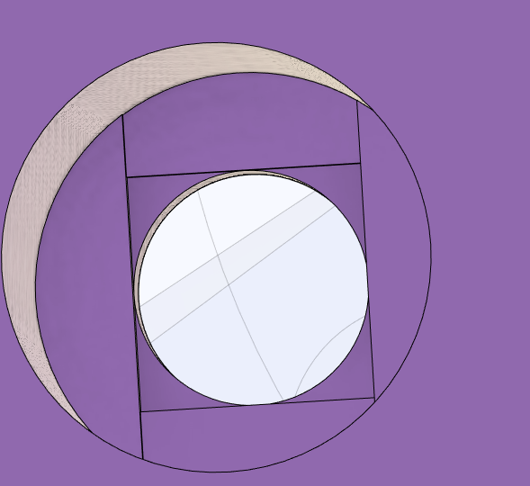

### ¼ -20 Open AT Adapter

This was added to fit the MMC standard ¼-20 and RAM mounting adapters. This was also inspired from the Oak design, however the thickness of the walls was also increased to 3.2 mm.

|  |  |
| --- | --- |
|  |  |
|  | |

### Inner Fillet

A fillet of 3.5 mm to match curvature of the bottom case.

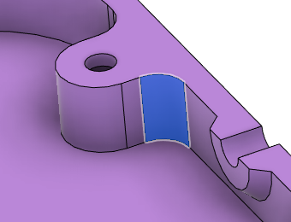

A fillet of 2 mm was added to reduce strain on joints and support for the screw channels. A 1mm fillet was added to the ¼-20 adapter features.

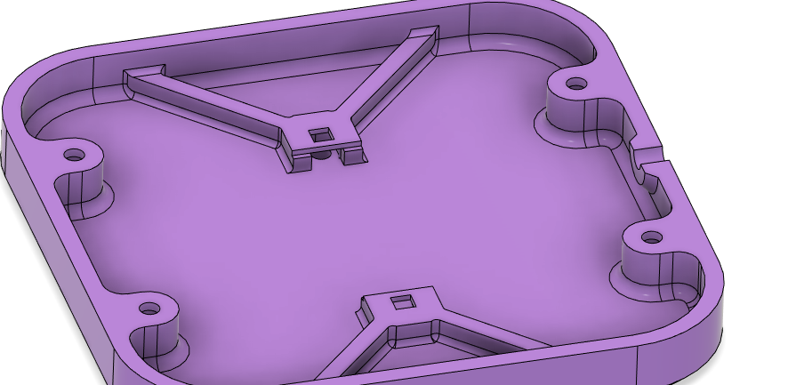

### Alignment to Top Enclosure

When extruding the channels and supports for the #4 screw to pass through, they protrude out of the bottom enclosure. By 0.25mm to reach the screw holes on the top enclosure. Fillets were added to this extension.

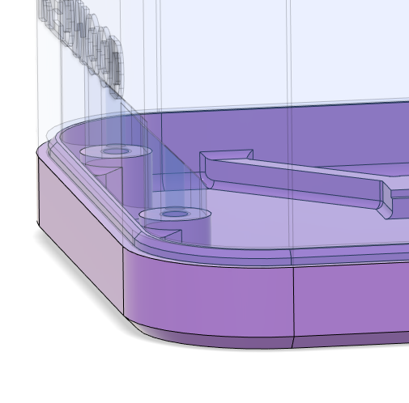

#### Placement of the top to bottom mounting holes

These mounting holes extruding from the corners of the enclosure with these dimensions of the body (95.5x95.5x56.35 mm (without stick)) will not work with the room needed for the USB to attach as can be seen in the photo below.

|  |  |
| --- | --- |
|  |  |

Therefore, the options are:

1. Move the mounting holes
   1. This will keep the joystick enclosure small
   2. Could result in strength issues. Further testing would be needed to see how much.
2. Increase enclosure length and width to accommodate
   1. Would increase dimensions significantly

Decision was made to move the mounting holes and slightly increase width and length to accommodate the cable. The final dimensions are 105.5x105.5x54.7 mm and the mounting holes were added to the side walls.

#### Shadow line

Adding a shadow line with 0.25 mm clearance for top and side alignment. This helps the esthetics and alignment of the case.

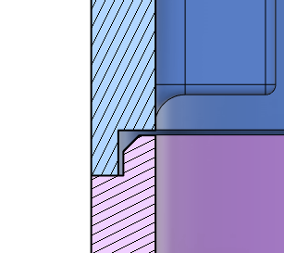

## Optimizing Overall dimensions

Can we make the enclosure smaller as there is quite a bit of extra room on the width and length?

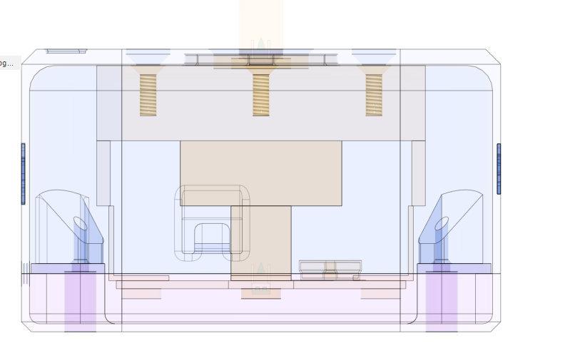

No, because of the room needed for the USB cable to be attached to the Ultrastik. The current dimensions are as small as the housing can be in this design. It is desirable to give more room as to not cause damage to the USB cable and in case the USB cable source changes.

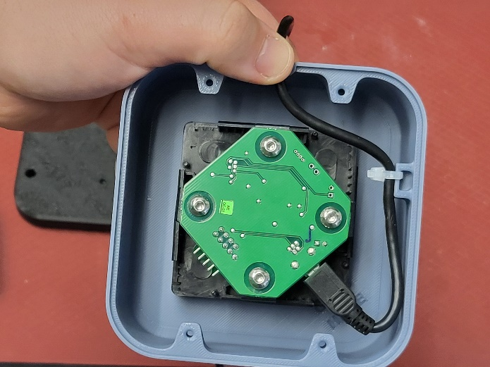

## Topper connection

* Design discussed in the Conceptual design - Concept 1 proved to work well during testing. Therefore, the only improvement that needs to be made to that design is a way to insert the M6 nut so there is no vertical translation when installing.
* This was done by adding a 3D print disk that is fit in place by a slot locking mechanism. The disk is slid in to the top of the topper nut after the M6 Nut and lined up with the 4 nubs on the inside. The disk then has a rectangular slot that a small coin or flat head screwdriver can turn to lock the nut in place.
* The disk also has a 7 mm hole in the middle so the M6 bolt can pass through with no interference.

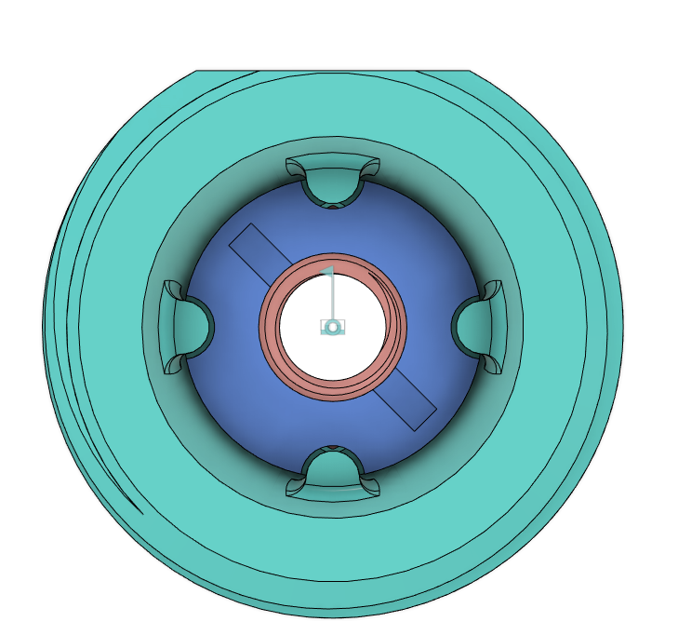

This was print tested and the nub that had a direct overhang failed. Therefore, that nub was removed on both the disk and topper nut.

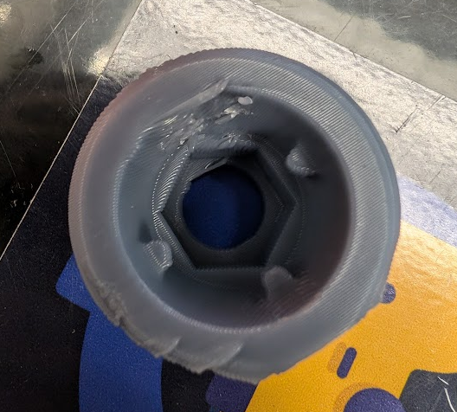

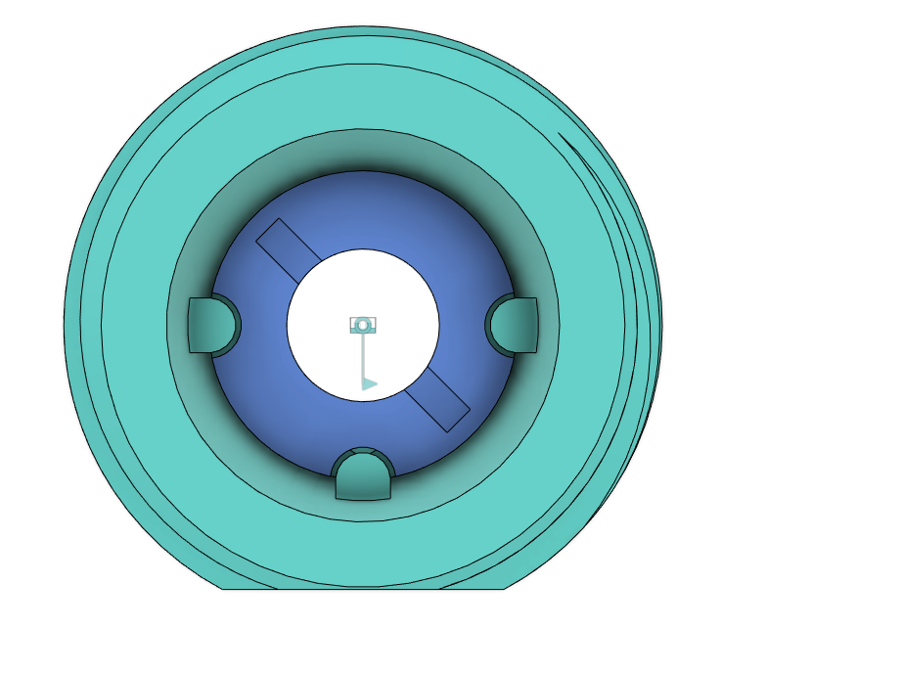

### Other options

A nut catch could have been added to the topper nut (similar to the features seen for the ¼-20 base). This was decided against as this is already a complex part and makers with less reliable/calibrated printers may have difficulty printing it. Also, the disk is not necessary to get the part to screw on. This is more of an assembly aid for those that may have difficulty holding the nut at the same time as threading.

## Comparison to SCCR Model

* SCCR: 109 x 91 x 59.5 mm
* MMC: 105.5x105.5x58.7 mm (without stick)

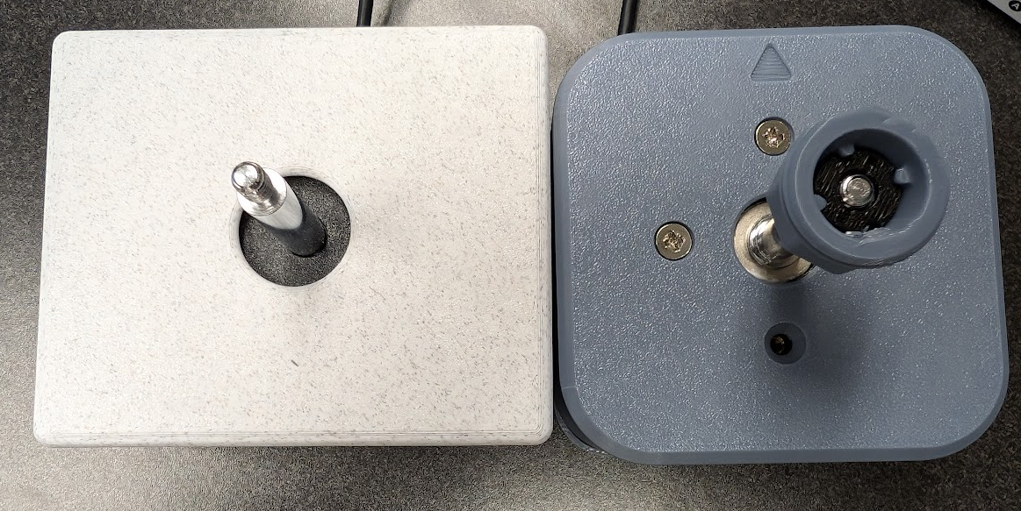

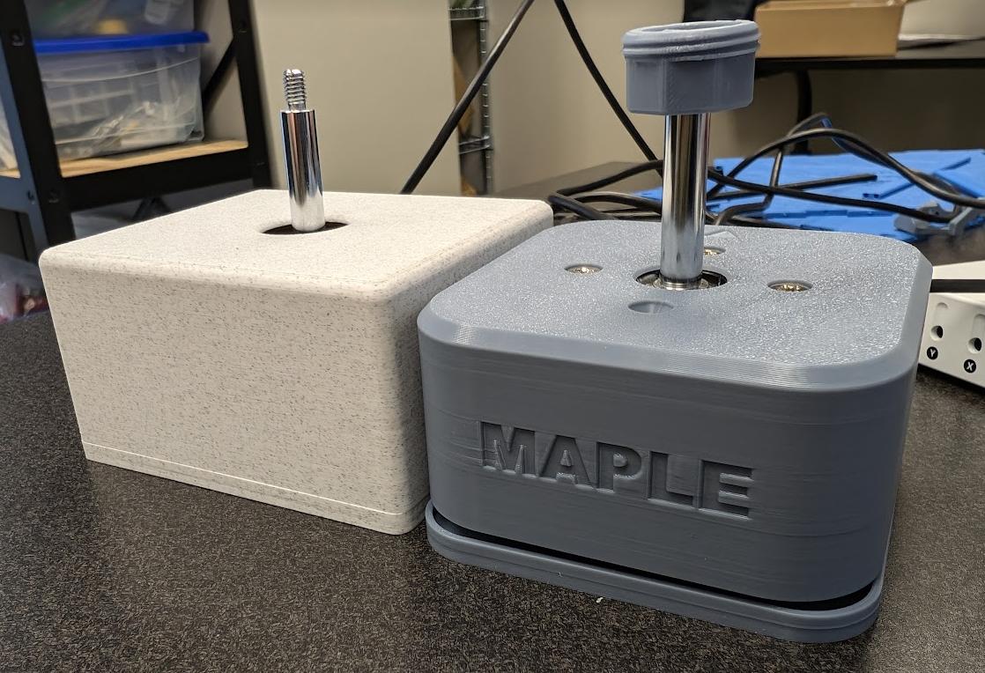

# Opportunities for Improvement

* Custom dust covers
* Ensuring correct orientation when assembling

# Design Validation

Aim of this section is to verify the requirements set by the design, user/maker validation, and any other validation required.

## Requirement Validation

Below are the goals, functional, and non-functional requirements from above. A column was added to evaluate if they were met or not.

### Goals

|  |  |  |
| --- | --- | --- |
|  |  | Was this met? (Y/N) |
| G01 | Act as a larger and durable form factor for our joystick line. | Y |
| G02 | Provide an option for users who are breaking the internals of the Oak Joystick. | Y |
| G03 | Maker manufacturable in quantities of one. | Y |
| G04 | The use of support material in 3d printed components should be minimized. | Y |
| G05 | The number of different filament types should be minimized. | Y |
| G07 | Material costs should be minimized as to provide a low cost options (Less than or equal to $100 CAD) | Y |

### Functional Requirements

|  |  |  |
| --- | --- | --- |
|  |  | Was this met? (Y/N) |
| F01 | The joystick shall be usable from a the distance given by the USB cable supplied by UltraStik | Y |
| F02 | The joysticks shall be compatible with the Xbox Adaptive Controller. | Y |
| F03 | Joysticks shall be PC compatible. | Y |
| F04 | The joystick shall denote use orientation. | Y |
| F05 | The joystick shall have a range of easily interchangeable toppers. | Y |
| F06 | Toppers shall not interfere with the regular physical motion of the joystick. | Y |
| F07 | Toppers shall have a secure connection to the joystick. | Y |
| F08 | The joystick shall be designed to be used by either hand. | Y |
| F09 | Joystick shall remain stable when in use. | Y |
| F10 | The housing shall protect internal components from outside sources. | Y |
| F11 | Joystick designs shall support camera mounting styles. | Y |
| F12 | Joystick designs shall support hook and loop fastener mounting styles. | Y |
| F13 | Joystick designs shall support tabletop mounting styles with no fasteners. | Y |
| F14 | Enclosure shall work with the Ultrastik joystick component | Y |

### Non-functional Requirement

|  |  |  |
| --- | --- | --- |
|  |  | Was this met? (Y/N) |
| NF01 | Documentation should be maintainable with the use of commonly available software. | Y |
| NF02 | Documentation must be available in a digital format. | Y |
| NF03 | Documentation must be printable. | Y |
| NF04 | Documentation, code, and hardware must have appropriate open-source licenses. | Y |
| NF05 | Instructions must be provided for using joystick with XAC for gaming | Y |
| NF06 | Instructions must be provided for using joystick with PC/Phone/Tablet for gaming | Y |
| NF07 | Instructions must be provided for using joystick with PC/Phone/Tablet for digital access | Y |

## User/Maker Validation

#### Foothills

* Sent to Foothills at Dec 6th, 2024
* First impressions feedback
  + “It is great to have a larger size joystick that is more durable”
  + “I have a client that I am seeing this will be perfect for”
  + “The joystick spinning will be challenging for the toppers that need to be aligned a certain way for the user”
* The centre will then keep the joystick and provide feedback once they work with gamers who it is suited for

### Dan

* Dan has a modified version of the Oak called the Mighty Oak as their unit was failing at the print lines with the regular Oak. He was interested in trialing the Redwood Joystick as an alternative.
* Joystick will be sent to him on __________

### Josie

* Josie is the only other MMC team currently with an Ultrastik Joystick. She has print tested and assembled the joystick with the following feedback on the design:
  + Joystick assembled easily and as expected
  + Works with XAC as expected

# Appendix A – Option of using a base with spacers already imbedded

This approach was explored and was abandoned. The thoughts around what hardware to use was archived in this appendix.

## Choosing the size of the faster

With a spacer design and not having a M5 machine screw already in our common parts, we have flexibility to choose a commonly available and lowest cost M5 machine screw length.

The common build event tools do not include any hex type drivers. With this, only Philips or slotted heads were considered.

|  |  |  |  |
| --- | --- | --- | --- |
| **Fastener** | **Cost for 4 (CAD)** | **Availability/source** | **Notes** |
| M5X10 – Philips | 13.15 | DigiKey – 200 in stock | Only come in pack of 100 |
| M5x12 – Philips | 13.15 | DigiKey – 200 in stock | Only come in pack of 100 |
| M5x8 - Philips | 9.19 | Amazon – only 8 left in stock | Pack of 20 |
| M5x10 – Philips | 12.89 | Amazon – only 3 left in stock | Pack of 50 |
| Hardware store (home depot) |  |  |  |

*Note that the stock was estimated as of Nov 13, 2024

With this, decide on M5X10.

### Spacer integrated

* Should the tunnel part be a cylinder? Would another shape print better?
* Are the screw drivers in the build kits long enough?
* Add some type of key for orientation so the cable comes out the right side
* Unsupported hole